Time Series Stationarity Test

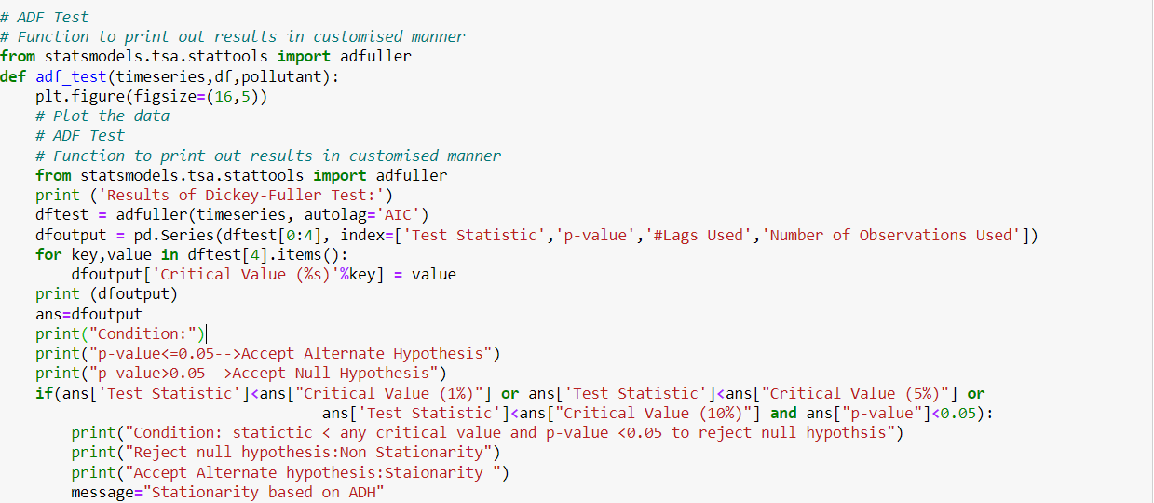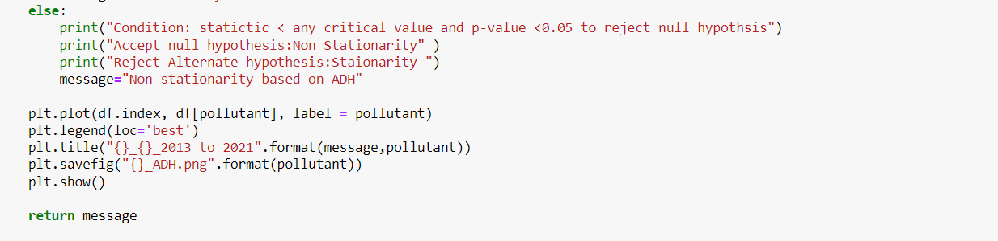

* + - It performs the Augmented Dickey Fuller test (ADF). Import adfuller function it performs ADF test.
    - That function takes three parameters timeseries, df, pollutant. Timeseries data performed ADF test. Polllutant is used for labeling plot.
    - Timeseries used for AIC parameter for lag selection within the dftest variable.
    - Output is stored in the dfoutput variable including statistic, p_value, critical values. It checks condition based on statstic, p_value, critical values to determine the hypothesis test. Loop is critical values stored in dftest[4] and each critical values entries on dropout variable its indicating the chance. Dropout variable can get statistic, critical and p_value and append for ans variable it’s easier to reference ADFtest.
    - If the statistic value is less than any critical value or the p_value is less than 0.05 it accepts the alternate hypothesis and rejects the null hypothesis and message it is Stationarity based on ADH. If the statistic value is greater than any critical value or the p_value is greater than 0.05 it accepts the null hypothesis and rejects the alternative hypothesis and message it is Non-Stationarity based on AD.H.
    - Plot the df.index Dataframe and the given values to plot the data. loc parameter its best location for placing the legend. Ploting the timeseries data and save the plot.
    - Next sets tittle of the plot statioarity or non stationarity message and save the file.